**DAILY ONLINE ACTIVITIES SUMMARY**

|  |  |  |  |  |  |  |  |  |
| --- | --- | --- | --- | --- | --- | --- | --- | --- |
| **Date:** | **07.09.20** | | | | | **Name:** | **RAVALI P** | |
| **Sem& Sec** | **6th& BSEC** | | | | | **USN:** | **4AL17CS076** | |
| **Online Class Summary** | | | | | | | | |
| **Subject** | | **System Software and Compiler Design** | | | | | | |
| **Max. Marks** | | **-** | | **Score** | | | **-** | |
| **Certification Course Summary** | | | | | | | | |
| **Course** | **Python for data structures** | | | | | | | |
| **Certificate Provider** | | | **coursera** | | **Duration** | | | **20hours** |
| **Coding Challenges** | | | | | | | | |
| **Problem Statement:Python Program for Find largest prime factor of a number** | | | | | | | | |
| **Status:executed** | | | | | | | | |
| **Uploaded the report in Github** | | | | | **yes** | | | |
| **If yes Repository name** | | | | | [**https://github.com/Ravalipr/Daily-Status.git**](https://github.com/Ravalipr/Daily-Status.git) | | | |
| **Uploaded the report in slack** | | | | | **yes** | | | |

**ONLINE CLASS**

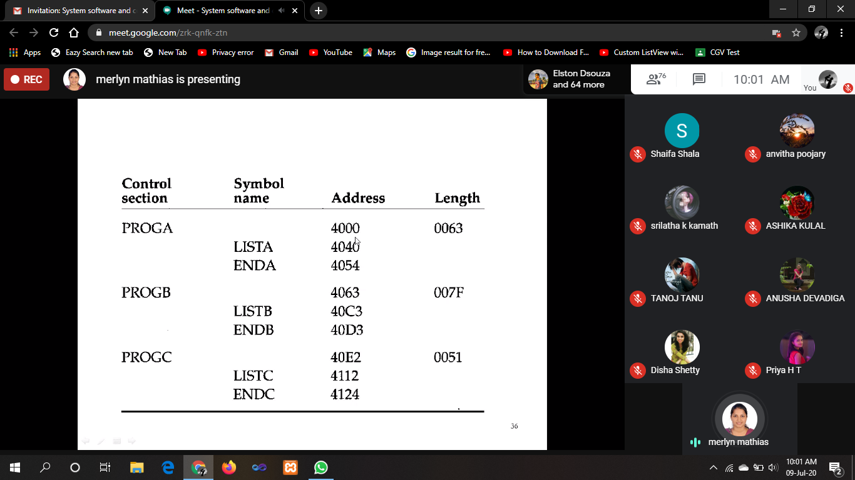

**ONLINE CERTIFICATION COURSE**

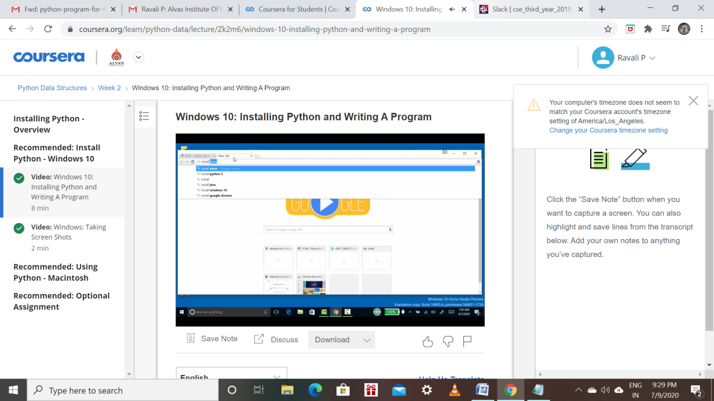

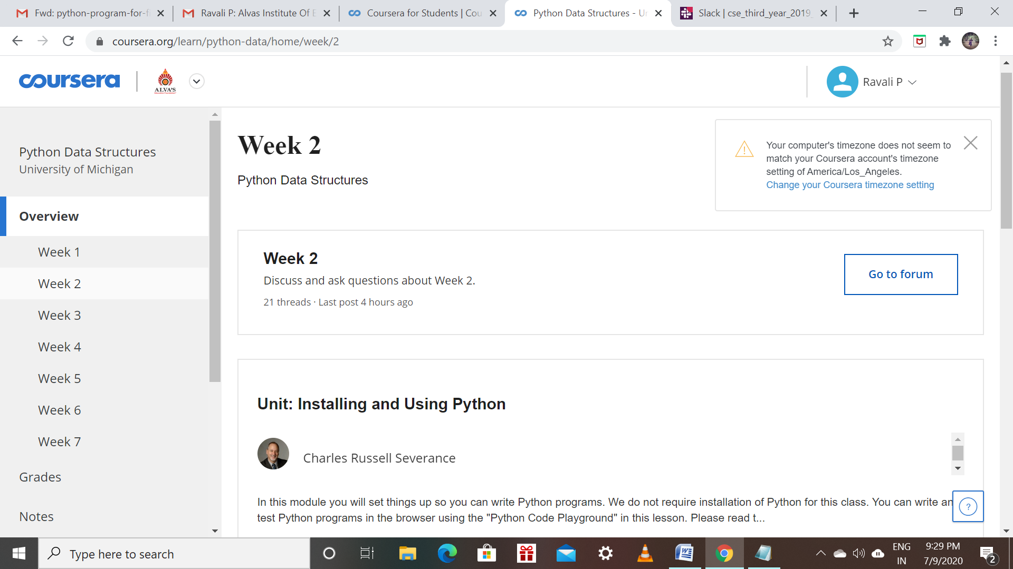

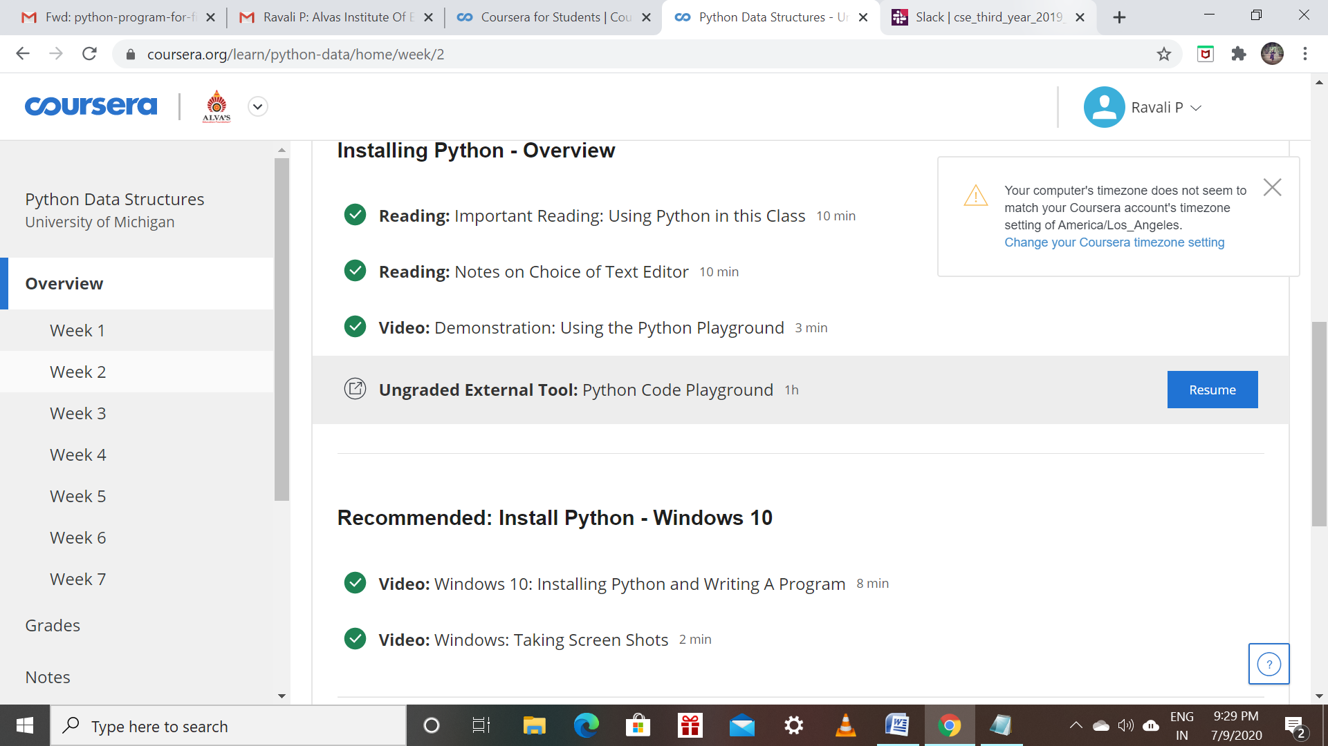

**ONLINE CODING**

**Python Program for Find largest prime factor of a number**

